Section 22: Disaster Recovery and Migrations

AWS Solution Architect Associate

# 261. Disaster Recovery in AWS

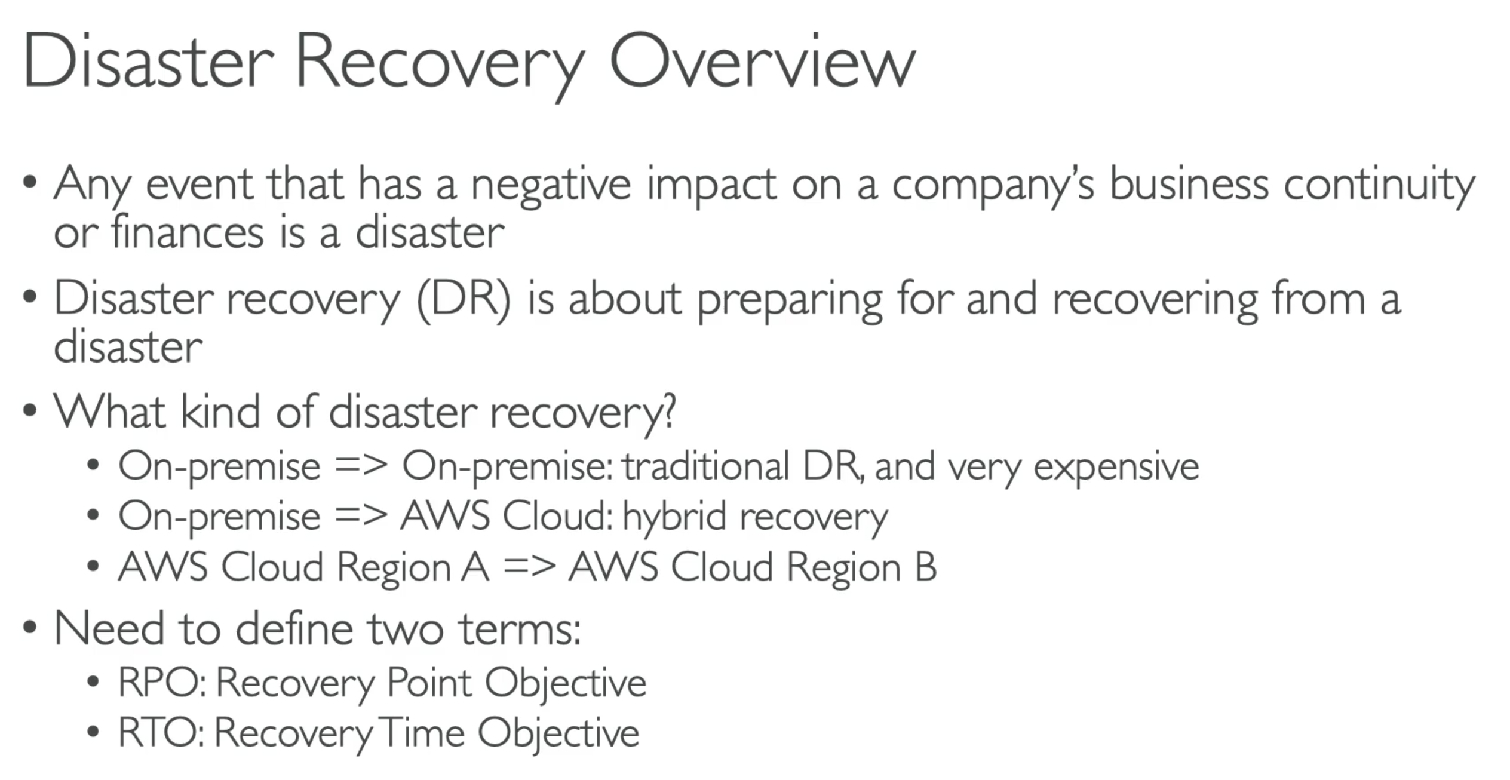

* RPO: How often you are on backups? At the time of disaster, the time between RPO and Disaster is your DATA LOSS.
* RTO: When you recover from a disaster, the time between disaster and RTO is DOWNTIME
* Smaller you want your RTO and RPO to be, higher is the cost

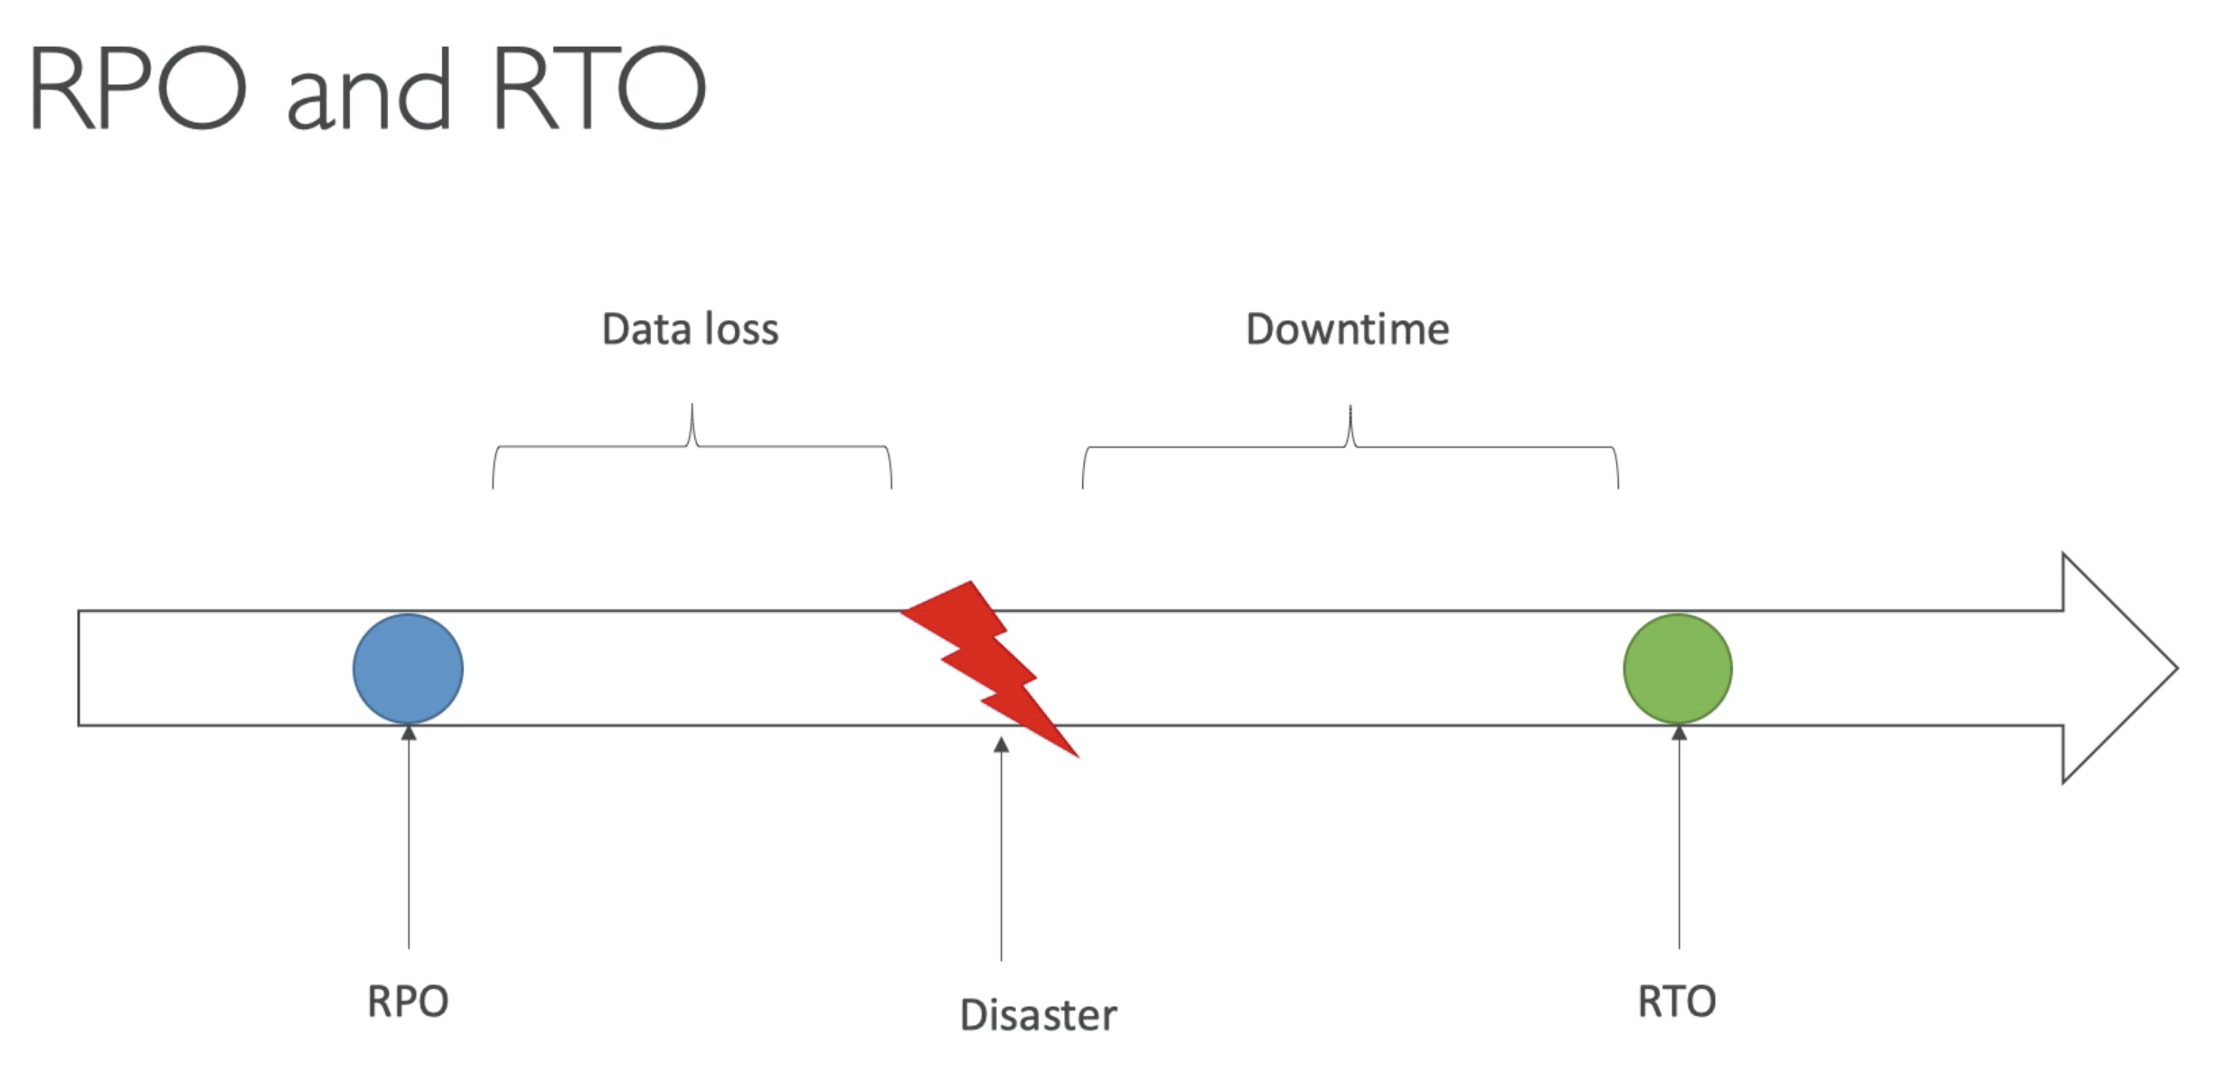

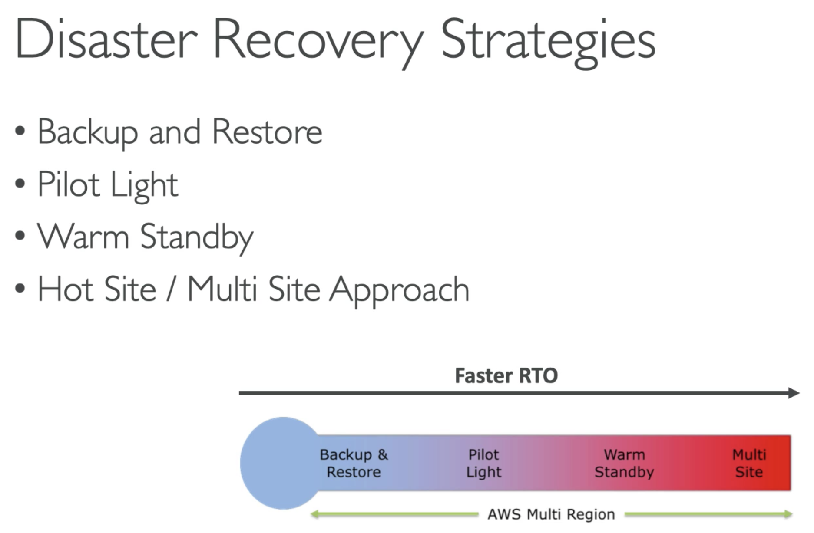

## Backup and Restore

* This is a cheap option – you are not managing any infrastructure in the middle. Rather you create it when required. The only cost we have is the cost of backups.

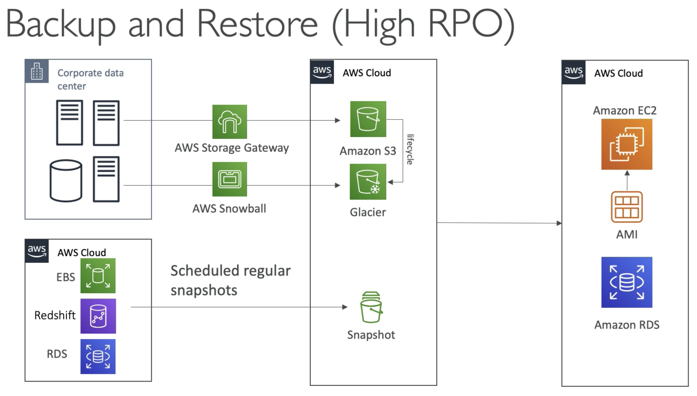

## Pilot Light

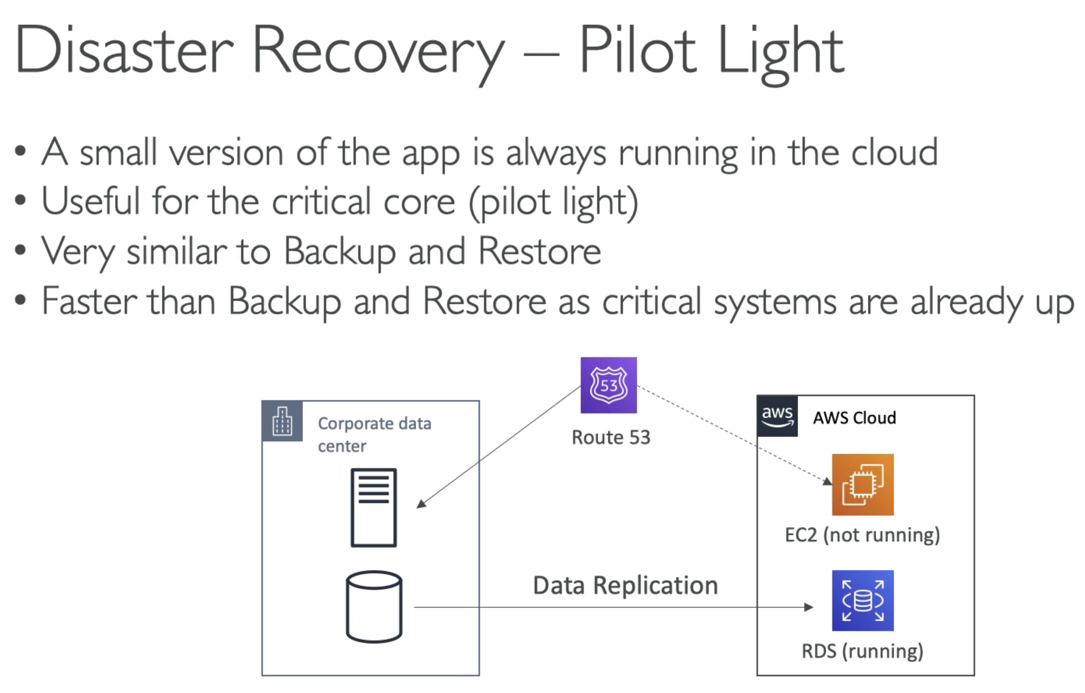

Example

* May be, you are doing continuous replication from your critical database to RDS on AWS. So RDS is always in running state. But EC2 instance is not running, as they are not that critical.
* In case of disaster, Route53 will fail over from your corporate data centre, recreate that instance in cloud and make it running….
* So here we get lower RTO, RPO and we still can manage the cost.

## Warm Standby

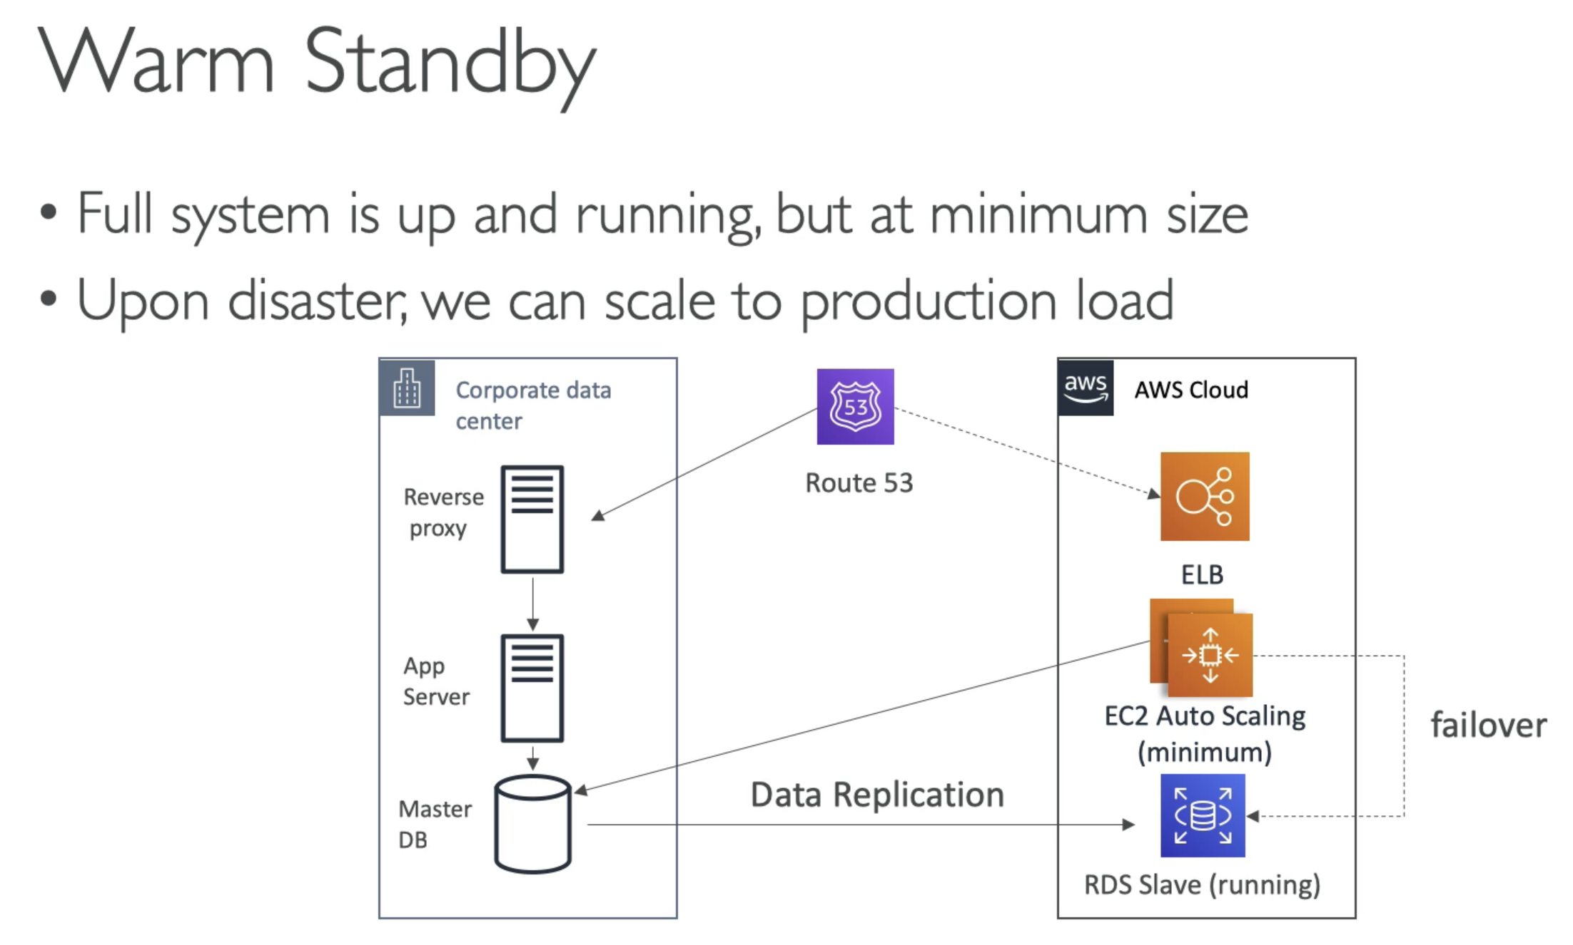

* In cloud we have continuous data replication, where a RDS Slave database is running
* We have a EC2 autoscaling group running at a minimum capacity, which is talking to Corporate DC database.
* May be We have an ELB as well
* If disaster strikes you, Route53 will failover to ELB, connect EC2 instance to RDS slave DB; with auto-scaling, may be the application will scale very quickly.
* It is a COSTLY option, because you have ELB, EC2 etc running …. but it can bring down your RTO and RPO…

Multi-Site

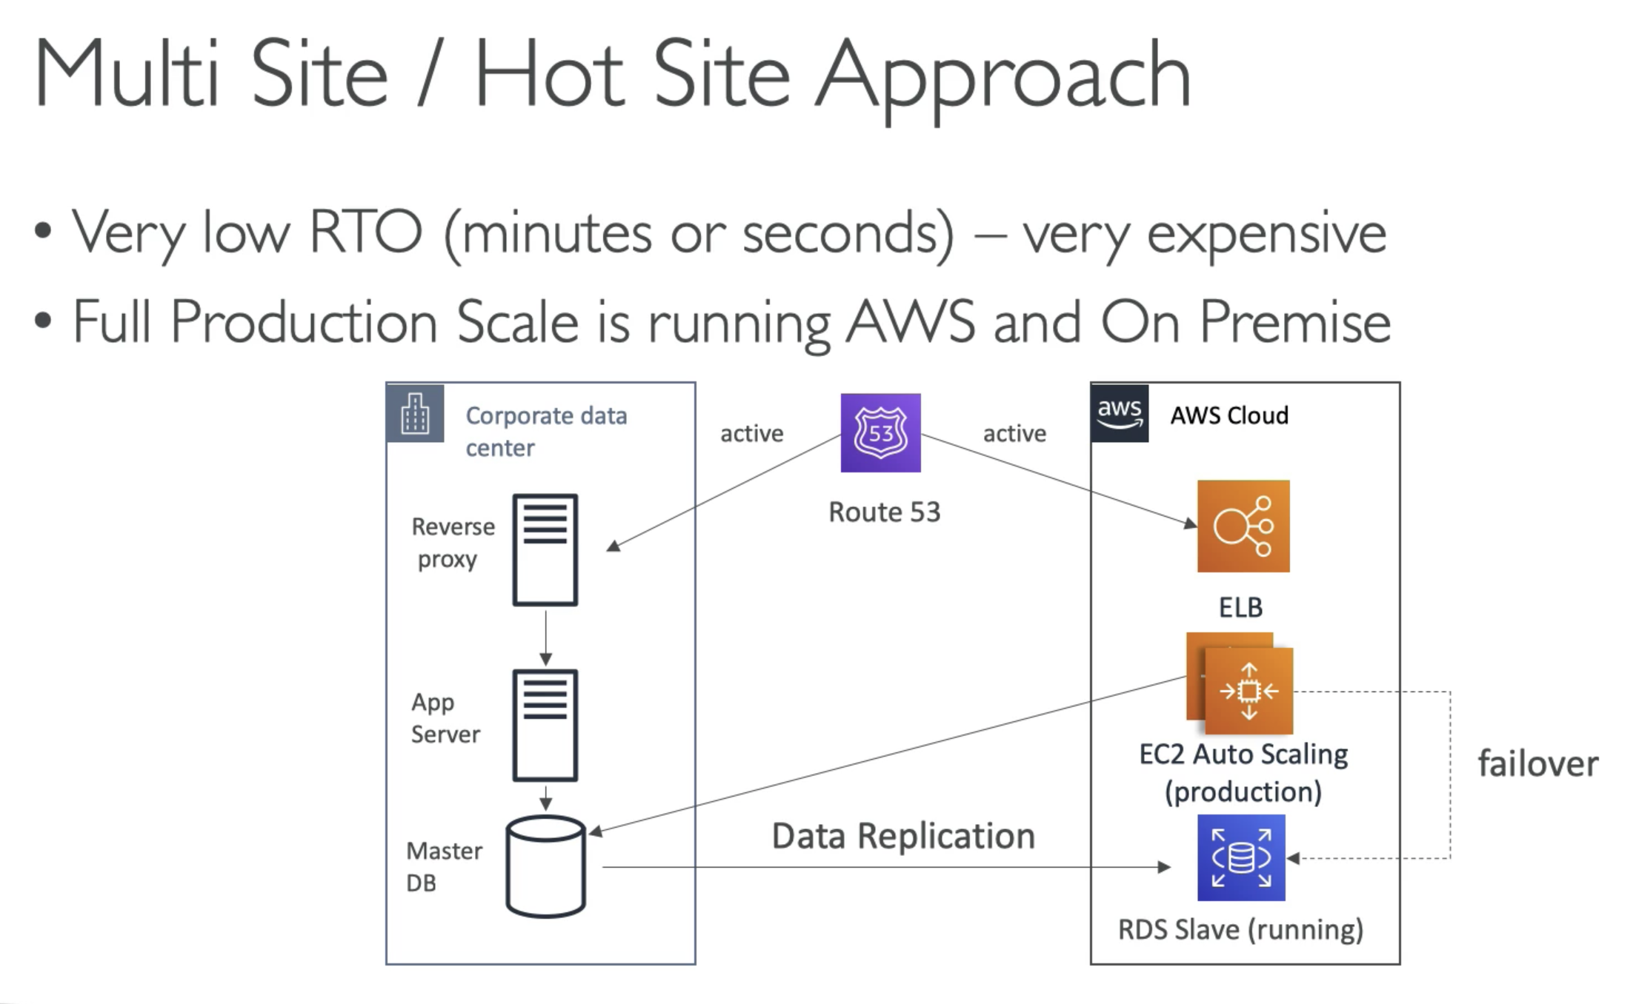

* Route53 can send traffic to Corp DC and AWS cloud instance
* In case of disaster, EC2 will failover to RDS slave DB, which is already running..

## All AWS Multi Region

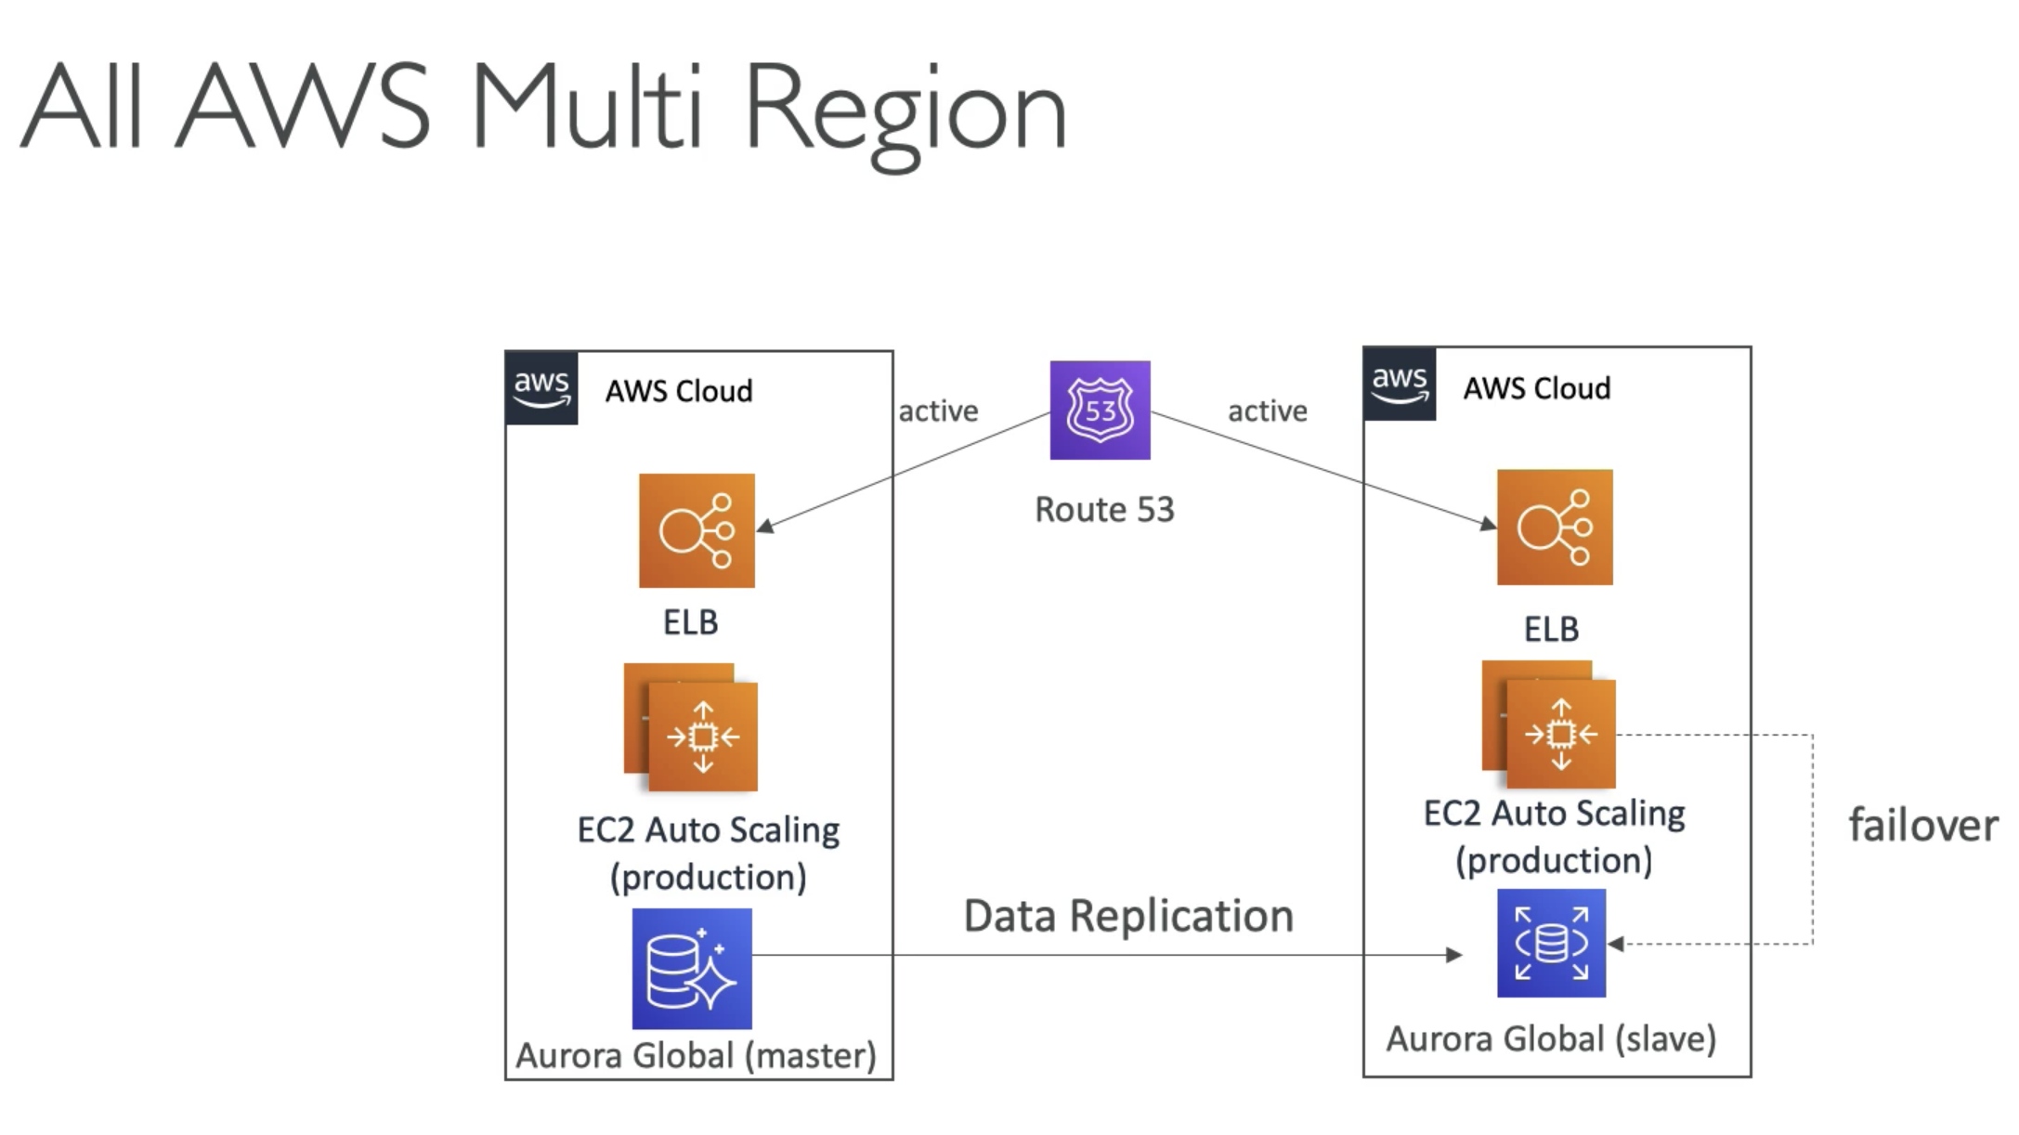

# 262. DMS – Database Migration Service

Remember: DMS is the database migration service.

SCT you will use if the source and the target database is different.

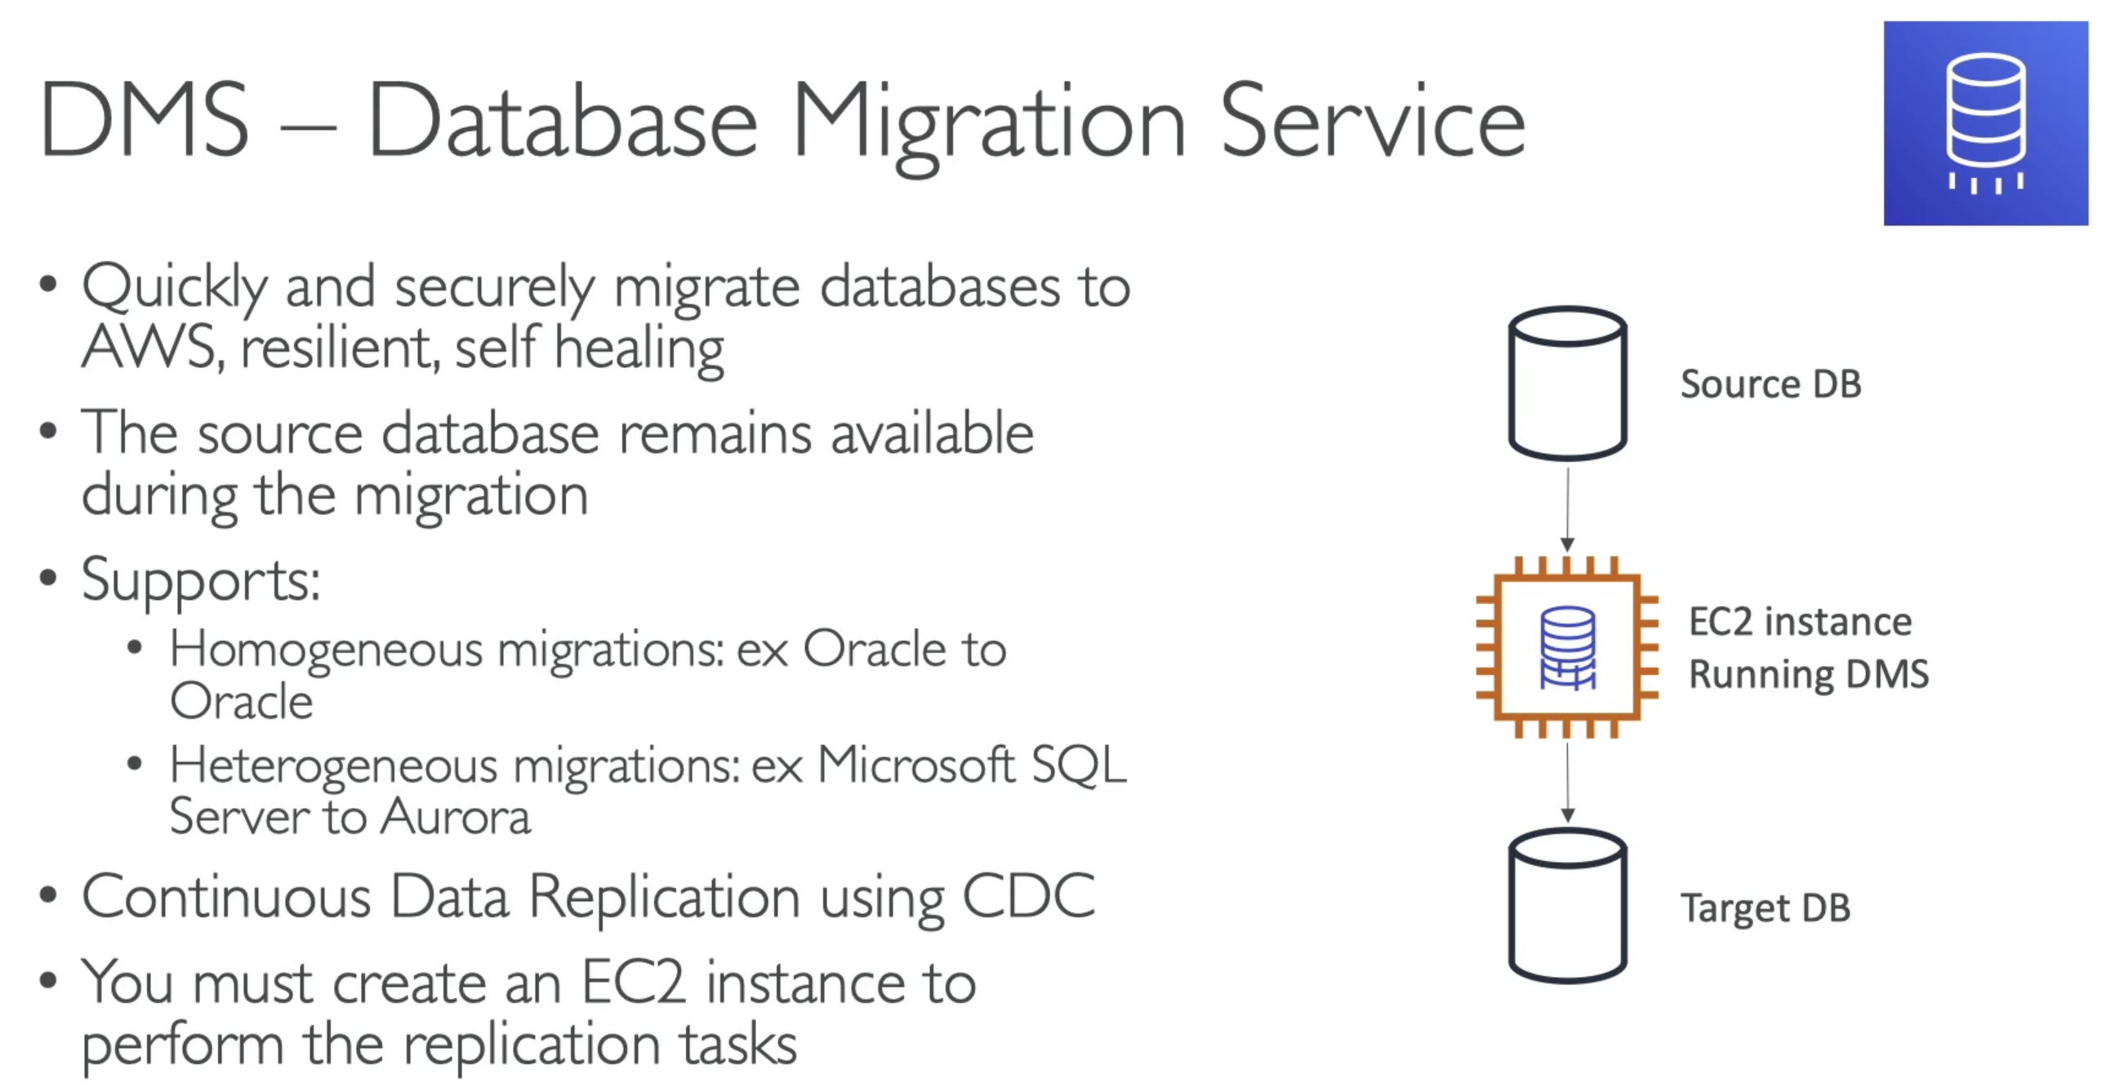

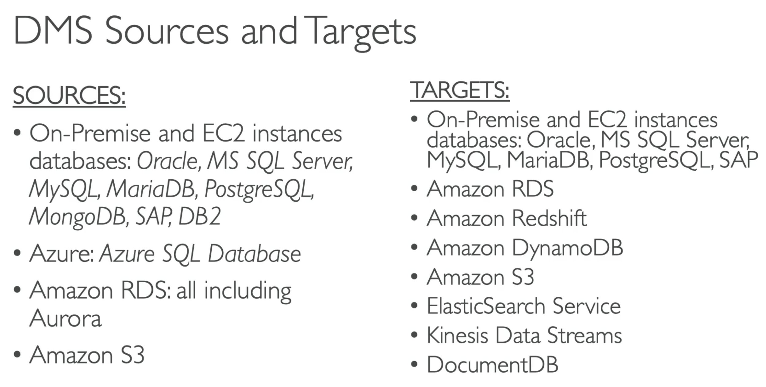

## SCT – Schema Conversion Tool

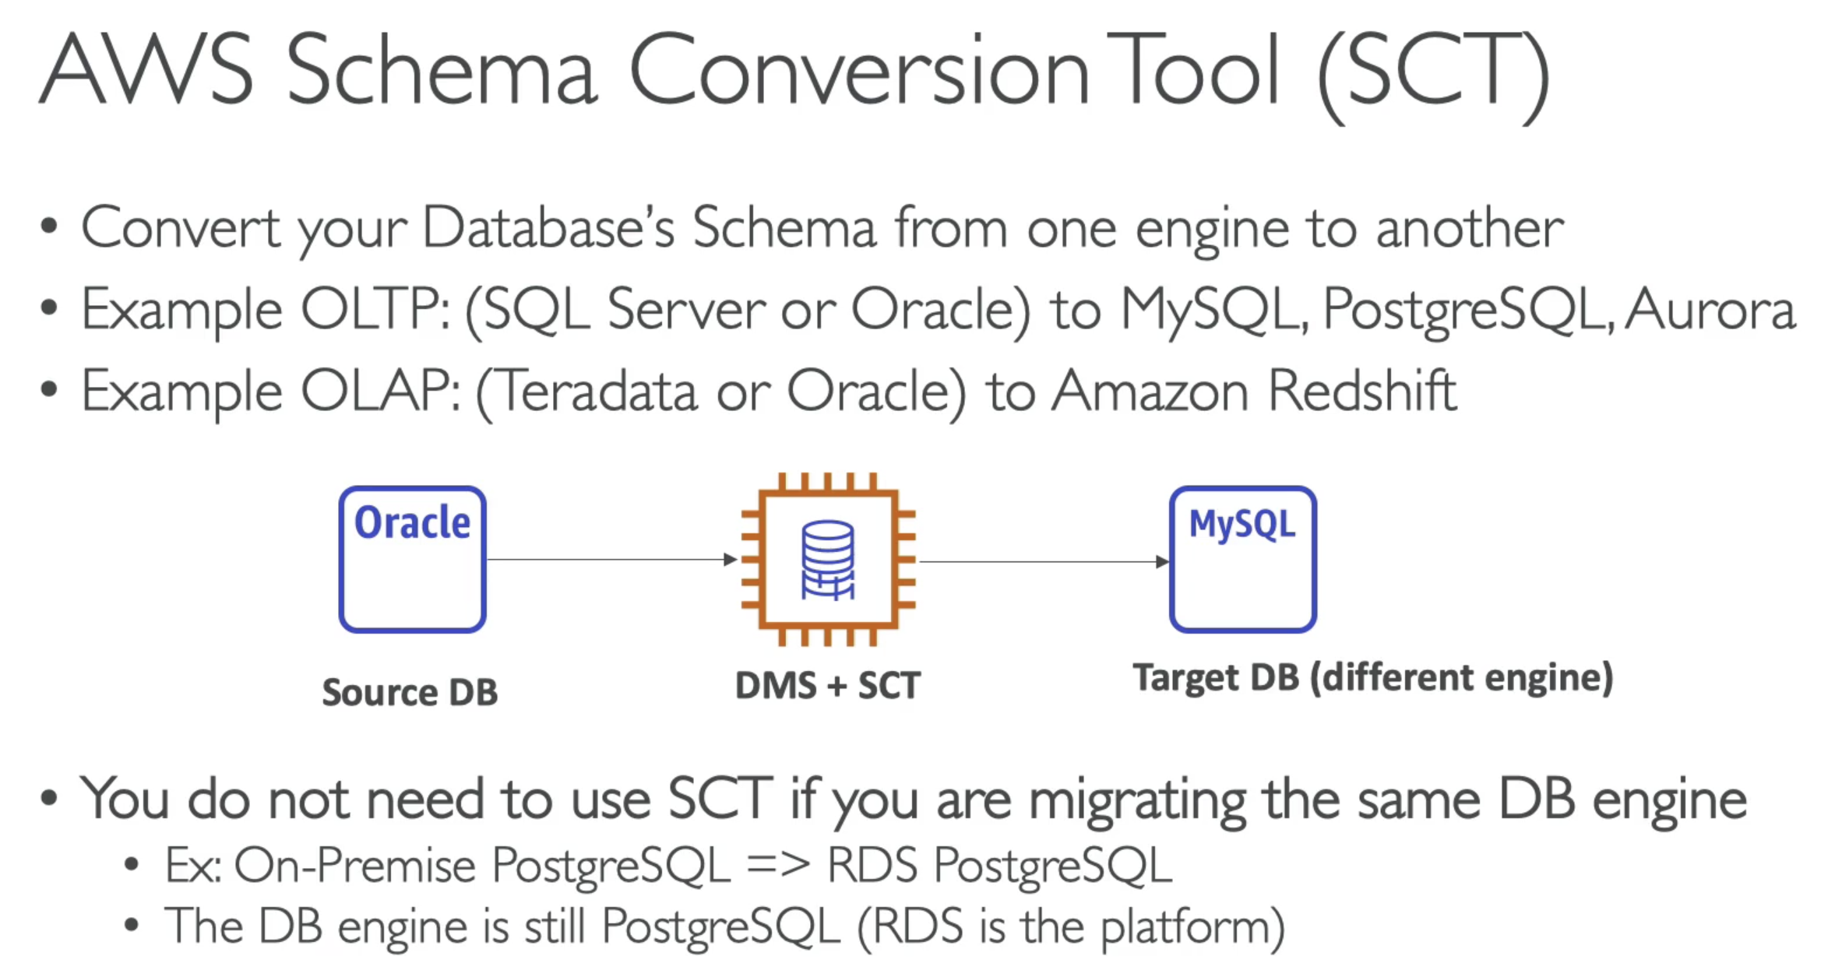

**ExamTip: you need to use SCT when you are migrating from two different databases…

# 264. **On Premise strategies with AWS

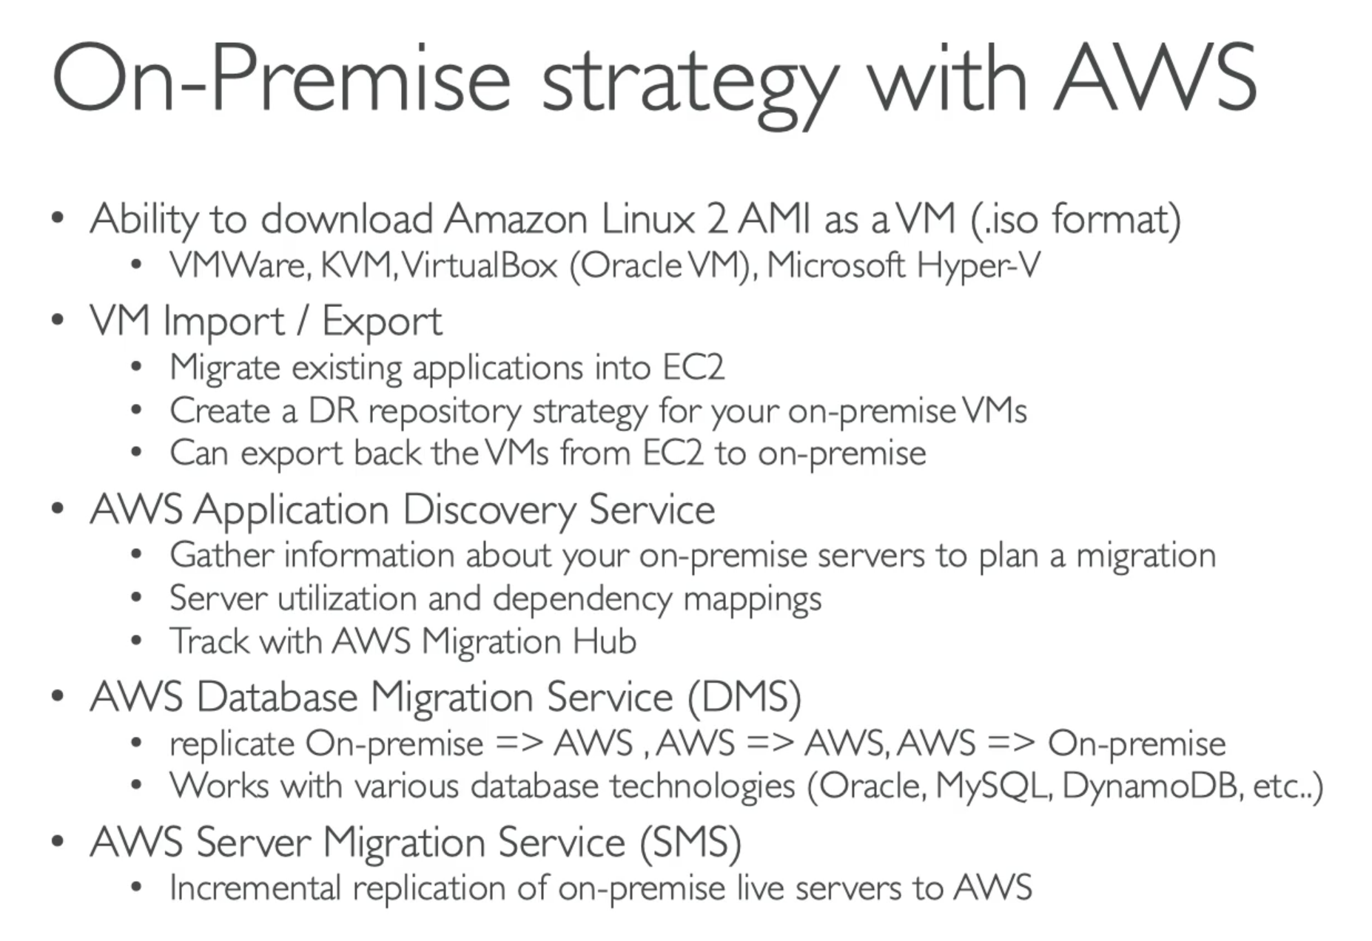

# 265. DataSync – Overview

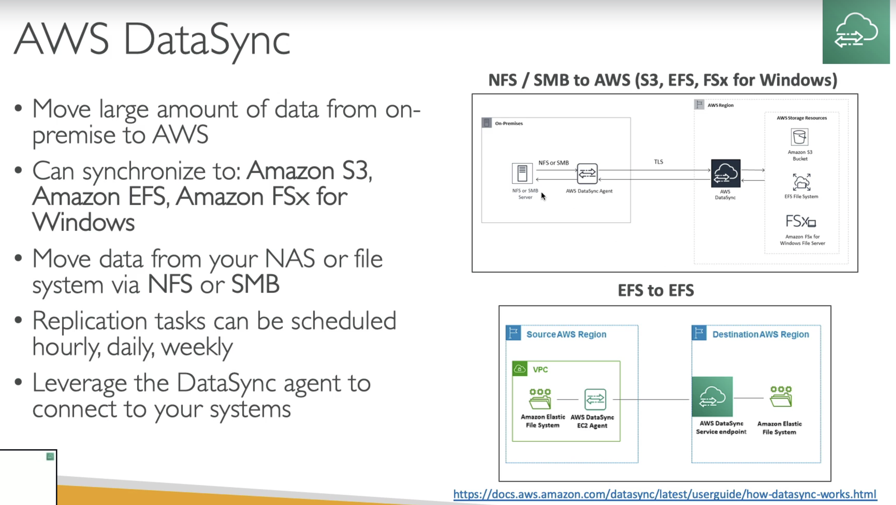

# 305. AWS Backup – Overview

